WEEK 3 TASK
ADVANCED DATA ANALYSIS AND VISUALIZATION IN LOGISTICS
Python-based Exploratory Data Analysis (EDA) Report
Prepared by: ____________________
Dataset type: Hypothetical / simulated logistics shipment data

1. Executive Summary
This report analyzes 250 simulated shipments to understand delivery performance, transportation costs, transport-mode differences, and regional service levels. Average delivery time was 3.74 days (median 3.55 days), average transportation cost was $375.23, and the overall on-time rate was 79.6%. The analysis uses descriptive statistics, distributions, group comparisons, correlation analysis, and five visualizations. Because the data is hypothetical, the results demonstrate an analytical method and should not be treated as actual company performance.

2. Objective and Questions
- Describe the distribution of delivery times, shipment sizes, distances, and transportation costs.
- Compare delivery time, cost, and on-time performance across transportation modes and regions.
- Examine relationships between distance, weight, shipment volume, delays, delivery time, and cost.
- Recommend operational actions based on observed patterns in the simulated data.

3. Dataset Description
The dataset contains 250 shipment records and 10 columns. Each row represents one shipment. It was generated for this assignment using Python random-number generation with a fixed seed so that results can be reproduced.
Variable | Type | Description
Shipment_ID | Categorical | Unique shipment identifier
Region | Categorical | North, South, East, West, or Central
Transport_Mode | Categorical | Road, Rail, Air, or Sea
Distance_km | Numeric | Shipment distance in kilometres
Weight_kg | Numeric | Shipment weight in kilograms
Shipment_Volume_units | Integer | Number of units in a shipment
Delivery_Time_days | Numeric | Observed delivery duration in days
Transportation_Cost_USD | Numeric | Simulated transportation cost in US dollars
Delay_Days | Integer | Simulated operational delay indicator in days
On_Time | Binary | 1 = on time; 0 = late, based on the simulation rule

4. Methodology and Tools
The analysis was performed with Python using pandas for data handling, NumPy for reproducible simulation and numerical work, and Matplotlib for charts. The workflow was: create the simulated dataset; inspect shape, data types and missing values; calculate descriptive statistics; group shipments by mode and region; calculate a correlation matrix; create visualizations; interpret results; and develop recommendations.
Data-quality checks: the dataset was checked for missing values and duplicate shipment identifiers. Missing cells: 0; duplicate Shipment_ID values: 0. Since the data is simulated, unusual values should be reviewed as examples of possible operational variation rather than real incidents.

5. Exploratory Data Analysis

5.1 Descriptive statistics
Metric | Mean | Median | Std. dev. | Minimum | Maximum
Distance km | 847.03 | 843.50 | 488.28 | 50.00 | 1797.00
Weight kg | 313.52 | 280.85 | 197.52 | 26.40 | 1072.30
Shipment Volume units | 59.48 | 59.50 | 34.92 | 2.00 | 119.00
Delivery Time days | 3.74 | 3.55 | 1.78 | 1.00 | 9.40
Transportation Cost USD | 375.23 | 301.84 | 309.14 | 34.20 | 2722.94
Delay Days | 1.04 | 1.00 | 1.31 | 0.00 | 5.00
Delivery time has a mean of 3.74 days and a median of 3.55 days. Comparing mean and median helps identify whether longer deliveries pull the average upward. Transportation cost averages $375.23; costs vary because distance, weight, mode, and shipment volume differ.

5.2 Distribution of delivery time
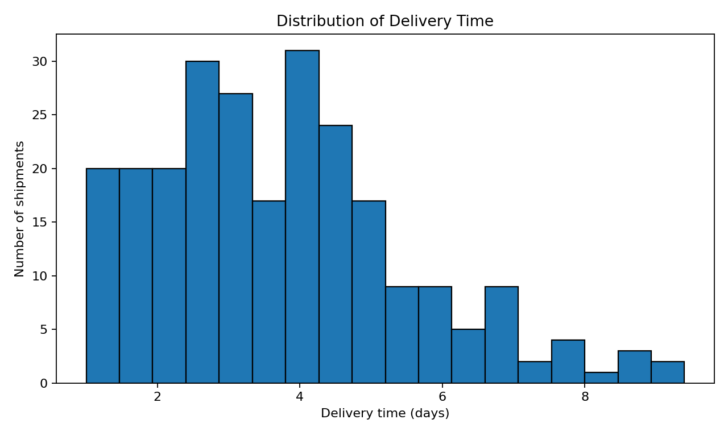
Why this chart: a histogram shows how frequently delivery durations occur and whether the distribution is concentrated, spread out, or right-skewed. Interpretation: most shipments cluster around the central delivery-time range, while a smaller number of longer deliveries form the upper tail. Those longer cases are useful candidates for delay investigation.

5.3 Delivery time by transportation mode
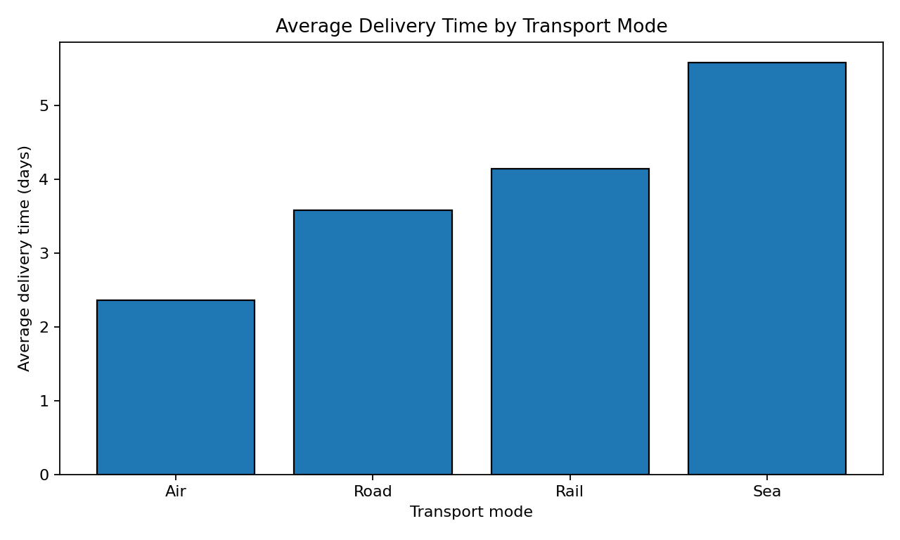
Why this chart: a bar chart makes average delivery time easy to compare across discrete transport categories. In this simulation, Air has the lowest average delivery time. Mode comparisons should be interpreted alongside distance, shipment type, and cost; a mode may be faster because it is assigned to different kinds of shipments.

5.4 Distance and transportation cost
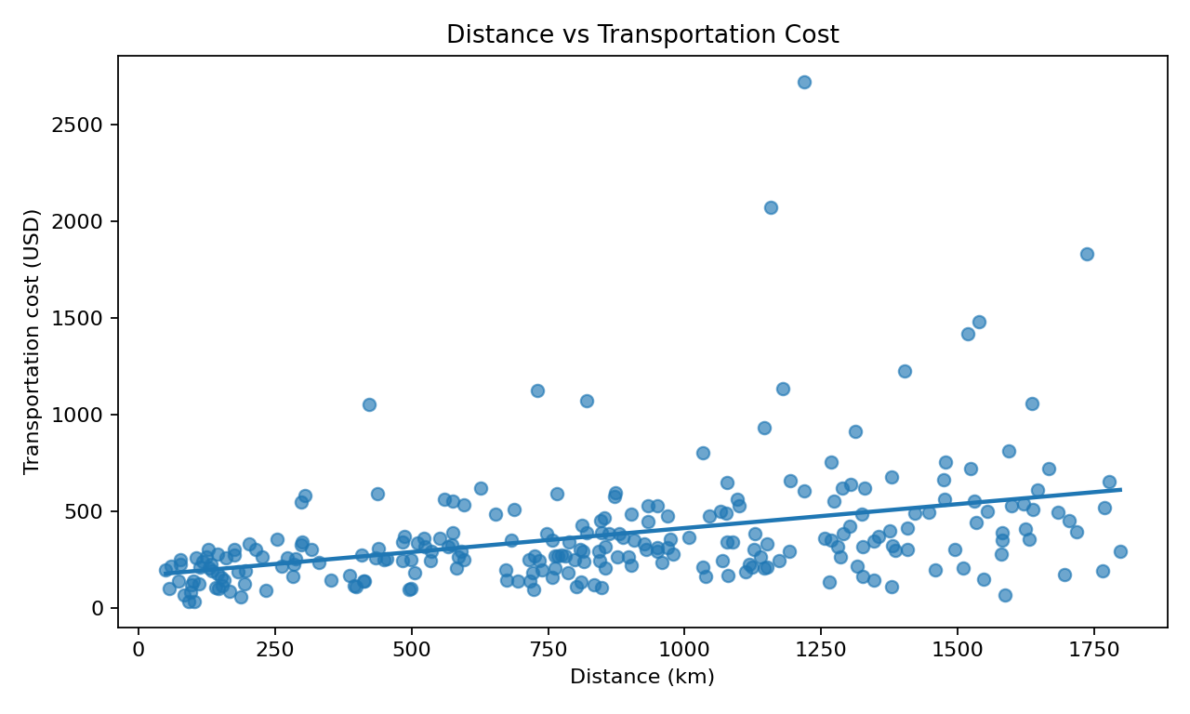
Why this chart: a scatter plot displays the relationship between two numeric variables and highlights spread or outliers. The Pearson correlation between distance and cost is 0.39. A positive relationship means longer routes generally tend to cost more in this simulated dataset, although weight and transport mode also affect individual shipment costs.

5.5 Correlation matrix
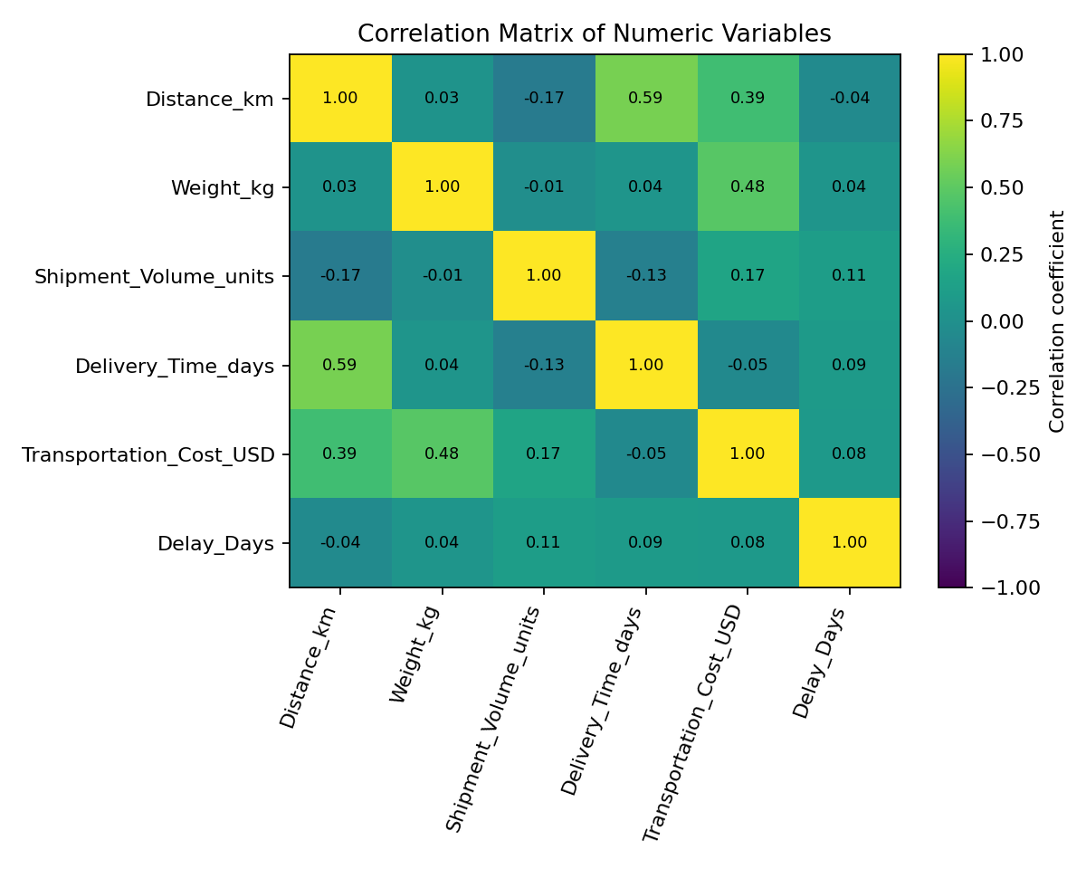
Why this chart: the correlation matrix summarizes linear relationships among numeric variables. Distance-cost correlation is 0.39; weight-cost correlation is 0.48; and delay-delivery-time correlation is 0.09. Correlation does not prove causation. For example, cost can be related to distance and weight simultaneously, so operational decisions should consider several factors together.

5.6 On-time delivery by region
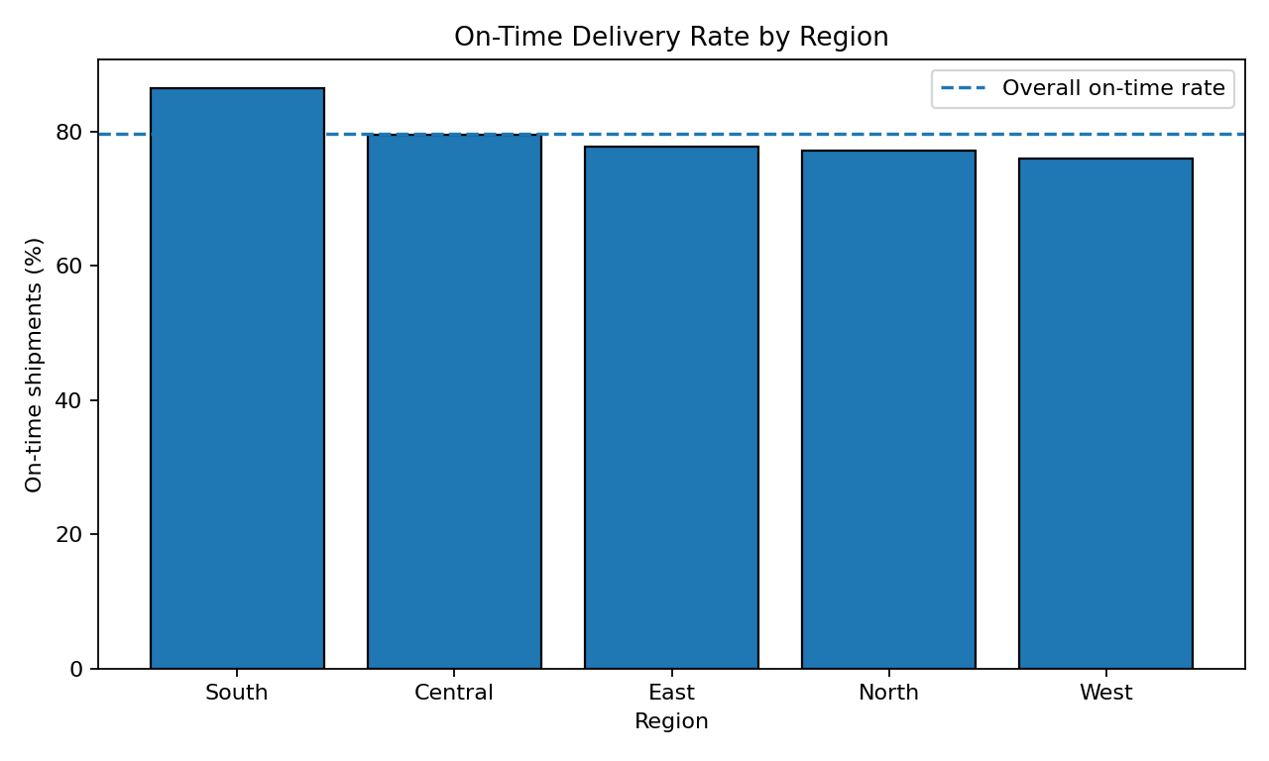
Why this chart: a regional bar chart compares service performance and makes variation between operating areas visible. South has the highest on-time rate (86.4%) and West has the lowest (75.9%) in this generated sample. The overall on-time rate is shown as a dashed reference line. Regional differences may reflect random variation in this small hypothetical sample and should be validated with real data.

6. Grouped Analysis

6.1 Transport mode summary
Mode | Shipments | Avg. days | Avg. cost (USD) | On-time rate
Air | 45 | 2.36 | $676.66 | 78.0%
Rail | 48 | 4.14 | $278.15 | 75.0%
Road | 123 | 3.58 | $339.98 | 79.0%
Sea | 34 | 5.58 | $240.84 | 91.0%

6.2 Regional summary
Region | Shipments | Avg. days | Avg. cost (USD) | On-time rate
Central | 44 | 4.16 | $350.05 | 80.0%
East | 36 | 3.51 | $375.17 | 78.0%
North | 57 | 3.60 | $399.51 | 77.0%
South | 59 | 3.72 | $355.40 | 86.0%
West | 54 | 3.72 | $391.82 | 76.0%

7. Key Findings
- The overall on-time delivery rate is 79.6%, which gives a baseline for tracking service performance.
- The average delivery time is 3.74 days, compared with a median of 3.55 days; the distribution chart helps identify unusually long shipments.
- Distance and transportation cost have a correlation of 0.39, suggesting that route length is an important cost-related factor in the simulated data.
- Weight and transportation cost have a correlation of 0.48; shipment characteristics should therefore be considered when comparing route or carrier costs.
- The fastest mode by average delivery time in this sample is Air; the lowest average-cost mode is Sea. These results are descriptive, not universal rankings.
- Regional on-time performance ranges from 75.9% to 86.4%, suggesting that region-level monitoring could help locate service gaps.

8. Recommendations
- Monitor delivery-time outliers weekly. Review late shipments by route, carrier, transport mode, and delay reason before changing service policies.
- Use distance, weight, volume, and transport mode together when comparing transportation costs; avoid judging a carrier from average cost alone.
- Create a regional KPI dashboard showing shipment count, average delivery time, cost per shipment, and on-time delivery percentage.
- Investigate the lowest-performing region using actual operational data, including warehouse processing time, dispatch schedules, traffic, weather, and carrier hand-offs.
- Evaluate speed-cost trade-offs. Reserve faster modes for time-sensitive shipments when the additional cost is justified by customer or business needs.
- Repeat this analysis over time and compare weekly/monthly performance so that improvements can be measured against a consistent baseline.

9. Limitations
The dataset is hypothetical and randomly generated. It does not represent a real logistics company, real carrier prices, or measured delivery performance. Some relationships are built into the simulation, and group differences can be affected by random sampling. The On_Time label is generated by a simple rule and is not based on a real customer service-level agreement. For real business decisions, replace the sample data with verified shipment records, document definitions, validate outliers, and consider confounding factors.

10. Conclusion
This task demonstrates how Python can turn shipment-level data into operational insights. Descriptive statistics summarize typical performance, histograms reveal delivery-time variation, bar charts compare categories, scatter plots explore cost drivers, and correlation analysis summarizes numeric relationships. The most useful next step is to apply the same reproducible workflow to real logistics data and track service, cost, and delay KPIs over time.

Appendix A: Python Code
The complete runnable script is provided separately as logistics_analysis.py. The following excerpt demonstrates the core analysis and visualization workflow:
import pandas as pd
import matplotlib.pyplot as plt
df = pd.read_csv("hypothetical_logistics_dataset.csv")
# Quick EDA
print(df.shape)
print(df.info())
print(df.isnull().sum())
print(df.describe(numeric_only=True))
# Group comparison
mode_summary = df.groupby("Transport_Mode").agg(
Avg_Delivery_Days=("Delivery_Time_days", "mean"),
Avg_Cost_USD=("Transportation_Cost_USD", "mean"),
On_Time_Rate=("On_Time", "mean")
)
print(mode_summary)
# Distribution chart
df["Delivery_Time_days"].hist(bins=18, edgecolor="black")
plt.title("Distribution of Delivery Time")
plt.xlabel("Delivery time (days)")
plt.ylabel("Number of shipments")
plt.tight_layout()
plt.show()
# Correlation analysis
print(df.select_dtypes("number").corr())

Appendix B: Files
Supporting files: hypothetical_logistics_dataset.csv (simulated data), logistics_analysis.py (reproducible Python analysis), and the PNG charts embedded in this report. Keep these files together in one folder when running the script.

